CS 340 Project Two README
About the Project/Project Title

This project is my interactive Animal Shelter Dashboard for the CS-340 course. I built it using Dash, Plotly, and Dash Leaflet. The main goal was to create a tool where users can explore animal shelter data in real time. The dashboard allows users to filter animals by type, view breed distribution in a chart, and see the exact location of selected animals on a map. It combines data from MongoDB with interactive visualizations, so anyone can quickly understand trends and details in the shelter’s dataset.

Motivation

My motivation for this project is to improve my skills in working with databases, Python dashboards, and visual data representation. I wanted to combine CRUD operations, Pandas data manipulation, Plotly charts, and maps into a single working application. My goal was to make the dashboard functional for a “client,” meaning someone at the animal shelter who might need to explore data quickly. It was also a challenge to make the interface interactive, user-friendly, and visually organized.

Getting Started

To run the project locally, here’s what I did:

- Clone or download the repository to your local machine or Codio workspace.
- Make sure Python 3.11+ is installed.
- Install the required Python libraries (listed below).
- Make sure MongoDB is running locally or accessible with your credentials.
- Open the project2dashboard.ipynb notebook in Jupyter Lab or Jupyter Notebook.
- Run all cells to launch the dashboard. It should appear inline in the notebook or open in a browser tab if you choose mode='external'.

Installation

I used the following tools to set up the dashboard:

- Python 3.11+
- Jupyter Lab or Jupyter Notebook
- MongoDB (local or hosted with credentials)
- Python libraries: Dash, Jupyter-Dash, Plotly, Pandas, Dash Leaflet, PyMongo
Install all necessary packages using pip:
pip install jupyter-dash dash dash-leaflet plotly pandas pymongo

Make sure your MongoDB database has the animals collection with data in the expected structure. I used my AnimalShelter CRUD module to read data from the collection.

Usage

Once the dashboard is running, users can:

- Filter the data table by animal type (e.g., dog, cat, water rescue).
- Sort columns and select rows to highlight data.
- View a pie chart of breed distribution for the filtered data.
- See a map that shows the location of the selected animal with tooltips and popups.

It’s designed to help someone quickly explore and understand the animal shelter’s dataset.

Example Usage

# Launch the dashboard in a new browser tab
app.run_server(mode='external')

After launching, I can select a row in the table, and the map will update automatically with the selected animal’s location. The pie chart also updates based on filters to show breed distribution.

Code Example

Here’s an example of connecting to the database and preparing data for the dashboard:

from animal_shelter import AnimalShelter
import pandas as pd
# Connect to the MongoDB database
db = AnimalShelter(username="aacuser", password="Password123")
# Read all animals from the collection
data = db.read({})
# Convert data to a Pandas DataFrame
df = pd.DataFrame.from_records(data)
# Drop the MongoDB '_id' column since it can cause issues in the dashboard
if '_id' in df.columns:
df.drop(columns=['_id'], inplace=True)

In my snippet, it shows how I loaded and cleaned the data before displaying it in the dashboard.

Tests

I manually tested the dashboard by:

- Filtering the data table to verify correct animals appear.
- Selecting rows to ensure the map updates with accurate coordinates.
- Checking that the pie chart correctly reflects the breed counts of filtered data.
- Highlighting columns to confirm the interactive table styling works.

No automated test scripts were used, but I confirmed all interactive features behave as expected.

Screenshots

Water Rescue

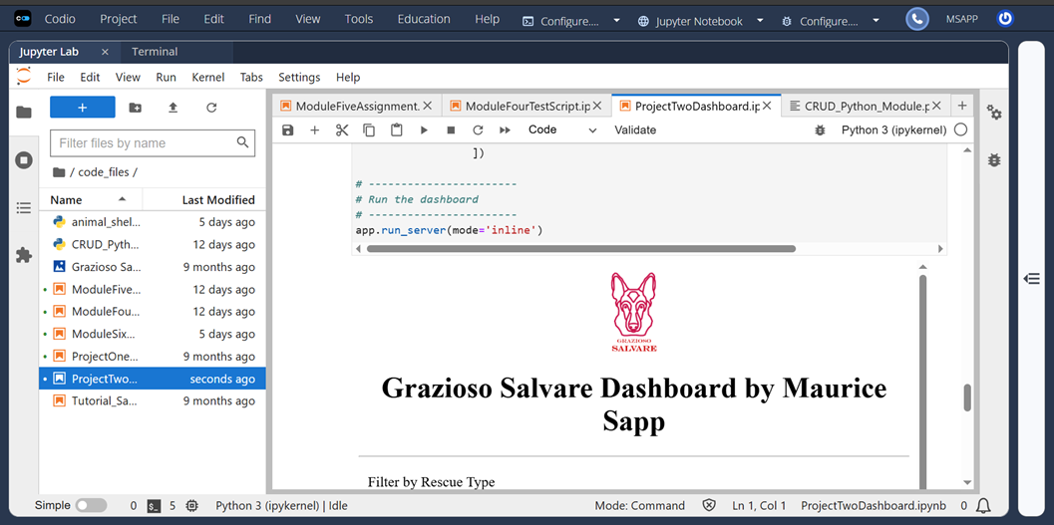

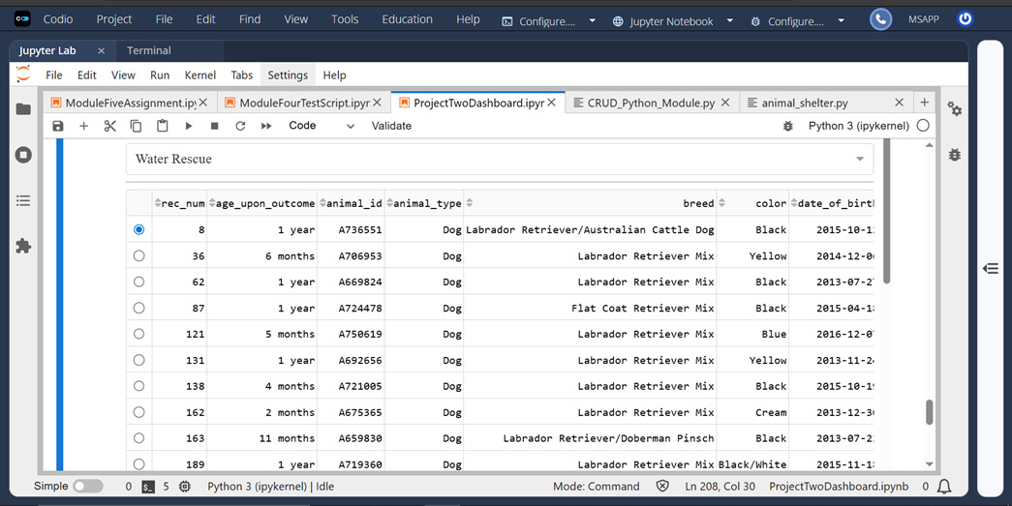

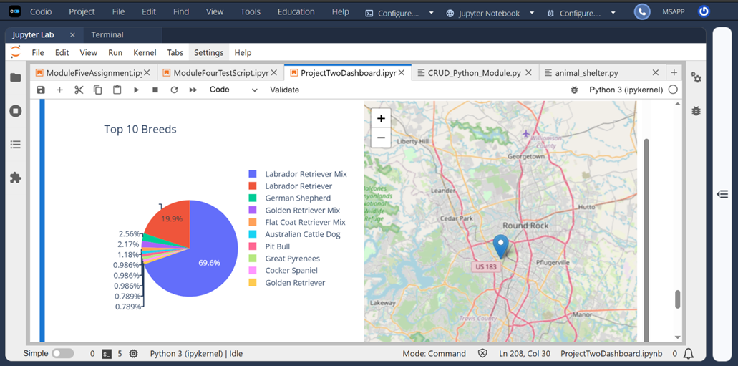

Mountain / Wilderness Rescue

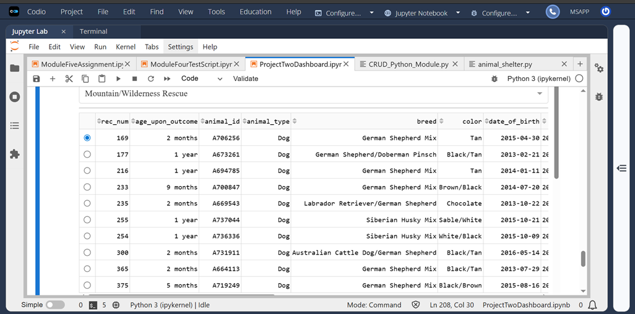

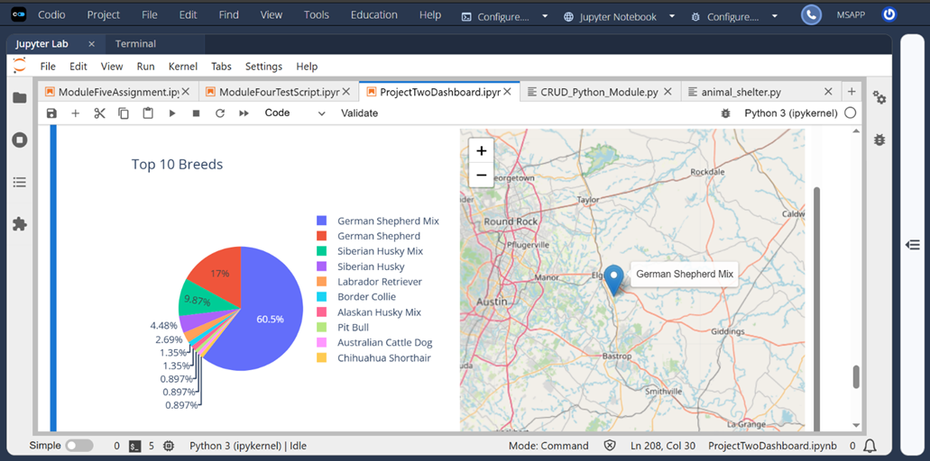

Disaster / Tracking

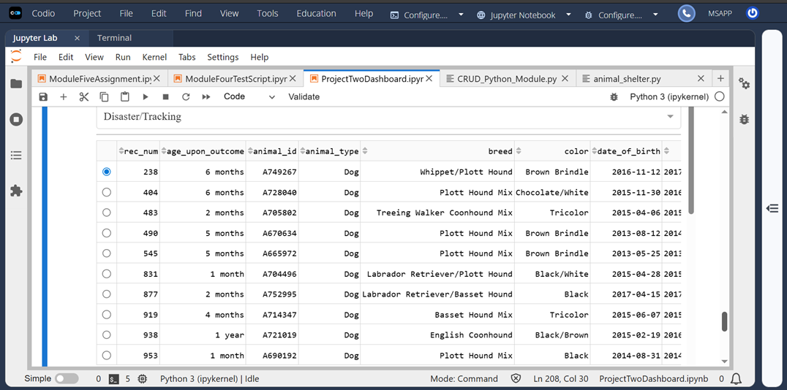

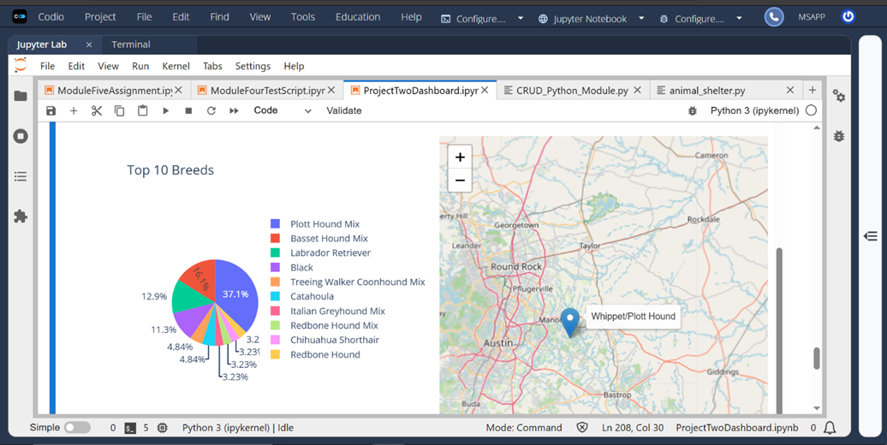

Reset

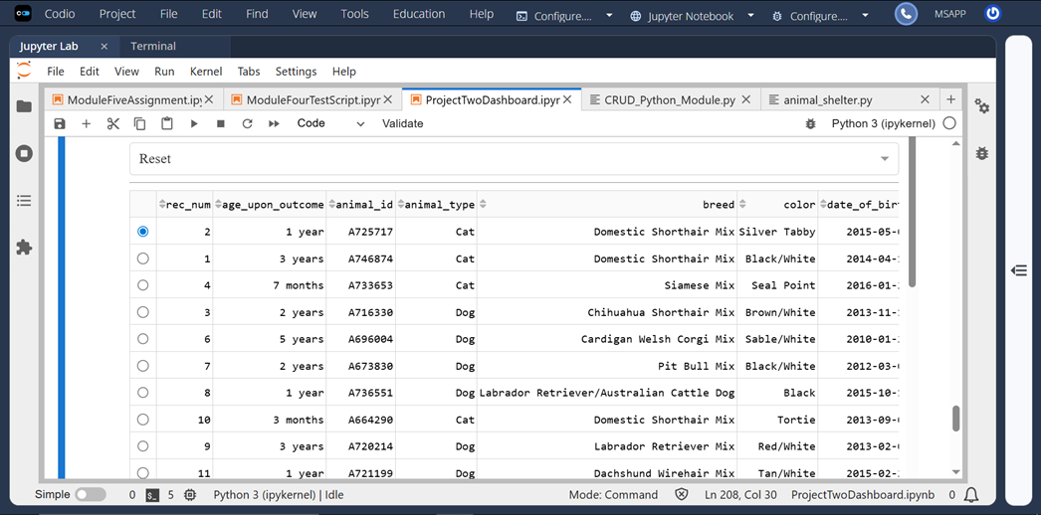

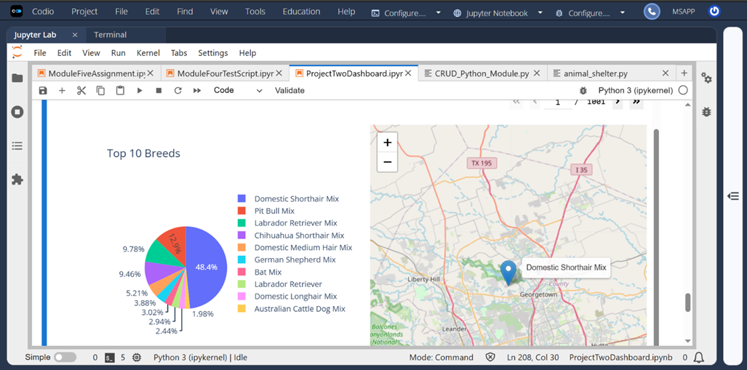

Roadmap/Features

Future improvements:

- Add more filtering options, like age or outcome status.
- Allow multi-row selection to show multiple animals on the map.
- Add download options for filtered data.
- Improve map interactivity with clustering for large datasets.

Contact
Maurice Sapp

